**Practical 4**

**Aim:** Docker Ubuntu commands

1. **To pull ubuntu image from docker registry**
2. Use ***docker pull ubuntu*** command – it pulls the latest version of ubuntu image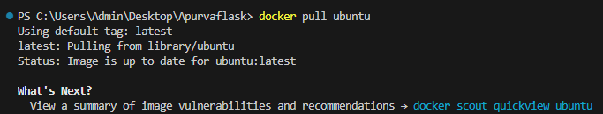
3. Use ***docker scout quickview ubuntu*** command – displays a quick overview of an image

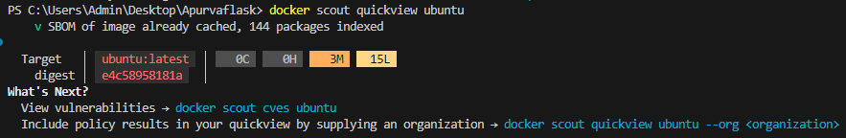

1. Use ***docker run -it ubuntu bash*** – to start an interactive Docker container based on the Ubuntu operating system image
2. Use ***echo “text to print”*** command - used to print text or display a message on the standard output (usually the terminal or command line).
3. Use ***touch filename.txt*** command to create an empty file in the current directory
4. Use ***exit*** command to exit from the ubuntu bash script

